18/10/2026 NAME: Charulatha.V
Experiment :6 REG.NO.:192424031
SLOT: A
SEMESTER:MS2 September 2026
COURSE CODE:CSA4701
COURSE NAME:Deep Learning

Gradient Descent, SGD, Momentum and Adam Comparison
Scenario:
A linear regression model predicts house prices but initially produces high prediction error. Implement gradient descent and visualize how the loss changes over successive iterations.
Algorithm:
- Start the program.
- Import NumPy, Pandas, TensorFlow, Keras, and Matplotlib libraries.
- Generate sample house-price data with random noise.
- Normalize the input features and target values.
- Define four optimizers: Gradient Descent, SGD, Momentum, and Adam.
- Create and compile a linear regression model for each optimizer.
- Train each model for 100 epochs and record the loss values.
- Calculate the initial loss, final loss, and loss reduction for each optimizer.
- Display the results in a summary table.
- Plot the loss curves to compare the training performance of all four optimizers.
- Analyze the loss reduction and identify the optimizer that converges effectively.
- Stop the program.
Source code:

import numpy as np
import pandas as pd
import matplotlib.pyplot as plt
import tensorflow as tf
from tensorflow import keras

# Generate sample house data
np.random.seed(42)
tf.random.set_seed(42)

X = np.linspace(500, 2500, 100).reshape(-1, 1)
y = 50 + 0.15 * X.ravel() + np.random.normal(0, 15, 100)

# Normalize data for stable training
X = (X - X.mean()) / X.std()
y_mean, y_std = y.mean(), y.std()
y_scaled = (y - y_mean) / y_std

# Define optimizers
optimizers = {
"Gradient Descent": keras.optimizers.SGD(learning_rate=0.01),
"SGD": keras.optimizers.SGD(learning_rate=0.01),
"Momentum": keras.optimizers.SGD(
learning_rate=0.01, momentum=0.9
),
"Adam": keras.optimizers.Adam(learning_rate=0.03)
}

results = []
loss_history = {}

# Train a separate linear model for each optimizer
for name, optimizer in optimizers.items():
model = keras.Sequential([
keras.layers.Input(shape=(1,)),
keras.layers.Dense(1)
])

model.compile(optimizer=optimizer, loss="mse")

# Record loss after each epoch
history = model.fit(
X, y_scaled,
epochs=100,
batch_size=16 if name == "SGD" else 100,
verbose=0,
shuffle=False
)

losses = history.history["loss"]
loss_history[name] = losses

results.append({
"Optimizer": name,
"Initial Loss": losses[0],
"Final Loss": losses[-1],
"Loss Reduction": losses[0] - losses[-1]
})

# Display summary table
summary = pd.DataFrame(results)

print("\nOPTIMIZER COMPARISON SUMMARY")
print(summary.to_string(index=False, formatters={
"Initial Loss": "{:.4f}".format,
"Final Loss": "{:.4f}".format,
"Loss Reduction": "{:.4f}".format
}))

# Plot loss over iterations
plt.figure(figsize=(9, 5))

for name, losses in loss_history.items():
plt.plot(range(1, len(losses) + 1), losses, label=name)

plt.xlabel("Epochs (Iterations)")
plt.ylabel("Mean Squared Error Loss")
plt.title("Gradient Descent Optimizer Comparison")
plt.legend()
plt.grid(True, alpha=0.3)
plt.tight_layout()
plt.show()

print("\nRESULT")
print("All four optimizers were trained and compared.")
print("The loss curves show how prediction error changes during training.")
Output:
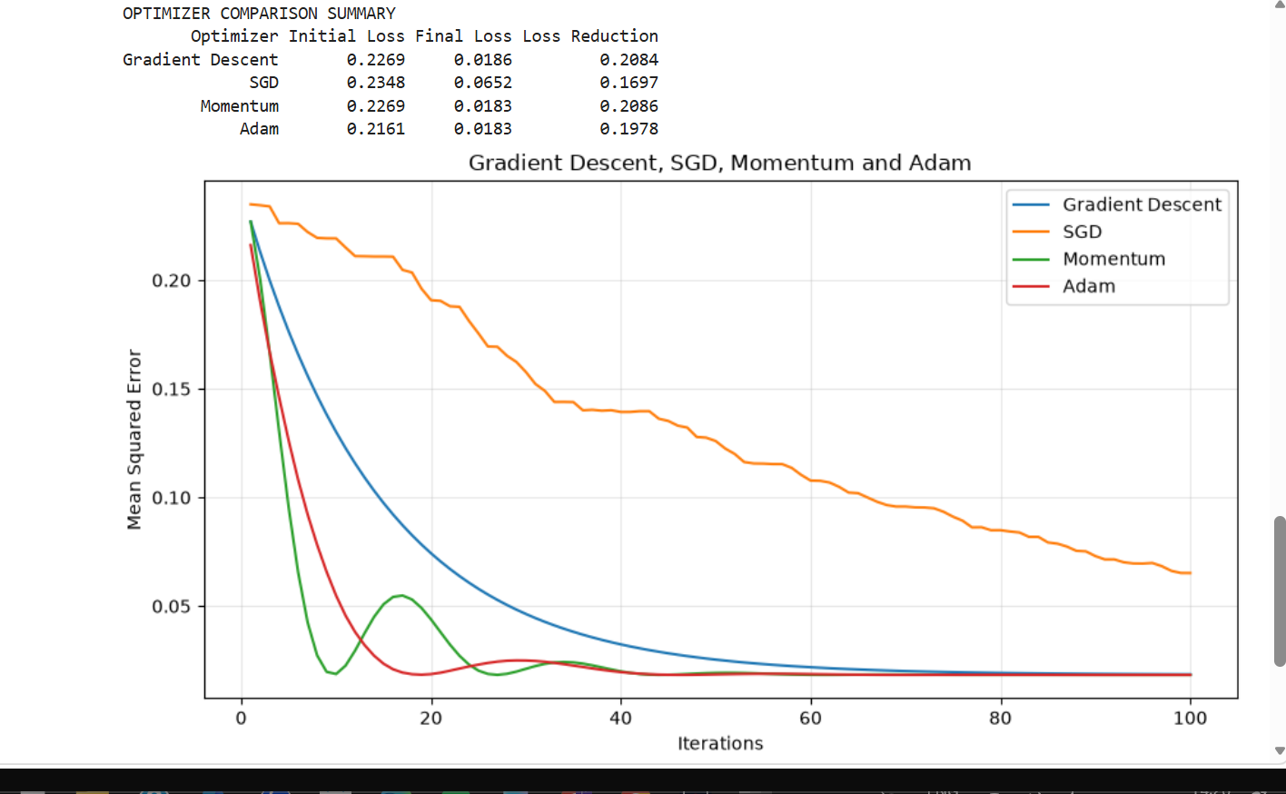

Result:
The four optimization methods were implemented using TensorFlow and Keras. Their initial and final losses are displayed in a summary table, and the loss curves visualize their training progress. Adam and Momentum may converge faster, depending on the learning rate and dataset.

